What: | An interactive and uplifting, sometimes surprising, and often very funny workshop focusing on the Enneagram, an ancient personal and professional growth discovery tool.
When: | Sunday, September 16th, 2018  From 9am to 3:30pm
Where: | Gainesville, FL
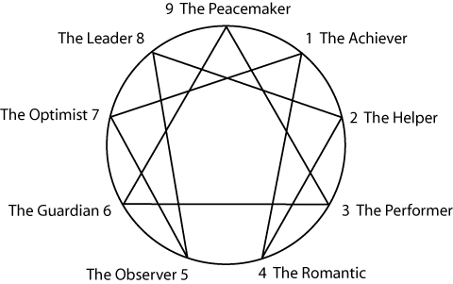
The Enneagram is about people - how we are the same, how we are different, what makes us tick. You will be amazed at the clear accurate portrayals of yourself and others you know.

The Enneagram is helpful in dozens of ways, including: personal growth, understanding relationships, improving communication, working with difficult people, and workplace/ business development.

This workshop will help you learn the Enneagram quickly and apply it towards the personal and professional goals most important to you.
Workshop Leaders: Donna LaBarge, PhD and Karin Kratina, PhD, RD, LDN
Donna is a Licensed Psychologist in private practice, with a PhD in Counseling Psychology. Karin is a nutrition therapist, with a PhD in Symbolic Anthropology, who has been studying personality systems for over 30 years. Both Karin and Donna have completed a year-long teachers training program and have a combined 20 years of enneagram experience.
Cost: $75 per person (Bring a lunch—or Subway is close by.)
Reserve your spot: contact Donna at 352-514-8165 or donnac2009@gmail.com
Advance registration is required.
Looking Ahead
Want to learn more? Reserve your seat for the next workshop -- Deeper Into the Enneagram: Uncovering Motivations, Strengths and Challenges, October 14, 2018. (The 9 Personality Types is a prerequisite.) We will also be offering discussion groups focusing on each of the enneatypes. Contact Donna with questions. Keep up with the Gainesville Enneagram Community at https://www.facebook.com/groups/GainesvilleEnneagram/, where we post upcoming events.

